

Statement Of Work (SOW)
Proposal For: Talaura Technologies
Migration (On-Premises to AWS)

Submitted By
Rapyder Cloud Solutions Pvt Ltd
Bangalore | Delhi | Mumbai
30th March, 2026

Document Detail
Date | 30th March, 2026
Signed between | Rapyder Cloud Solutions Pvt. Ltd. & Talaura Technologies

Customer Representative Contact Details
Name | Mr.
Mobile Number | +91
E-Mail

Rapyder Group Representative Contact Details
Name
Mobile Number
E-Mail

Rapyder Solutions Architect Contact Details
Name | Mr. Hassan Shahid
Mobile Number | +91 8240838140
E-Mail | hassan.shahid@rapyder.com

Document Revision History
Date | Version | Content | Author | Reviewer/Date | Approver/ Date
30th March, 2026 | 1.0 | Initial Version | Mr. Hassan Shahid | Mr. Zainuddin H  31st March, 2026 | Mr. Zainuddin H  31st March, 2026
Important Notice: This document and any attachments submitted with it are confidential and intended solely for the use of the individual or entity to which it is addressed. If you are not the intended recipient, you are hereby notified that any use, dissemination, forwarding, printing, copying or other use of this document, any attached documents, and the information these documents contain is strictly prohibited. If you have received this by mistake, please advise the sender immediately and destroy/invalidate the document.

Contents
1 About Rapyder 6
2 Our Offerings 7
2.1 Portfolio 7
2.2 AWS Services Expertise 7
3 Business Background 8
4 Customer Project(s) Overview 8
5 Problem Statement 8
6 Document Objective 8
7 Success Criteria 9
8 Proposed Solution & Architecture 9
8.1 Implementation Approach 9
8.1.1 Architectural considerations 9
8.1.2 Architecture Diagram – Infrastructure 11
8.2 Assumptions 11
8.3 Out of Scope: 11
8.4 Best Practices recommendations & inclusions 12
8.4.1 Compute Options 12
8.4.2 Security considerations 12
8.4.3 Monitoring and Logging 12
8.4.4 Storage 12
8.4.5 Backups 13
8.4.6 Databases/Services used 13
8.4.7 DevOps tools 13
8.4.8 Big Data 13
8.4.9 AI/ML 14
9 Migration/Implementation 14
9.1 Approach for AWS Environment Setup 14
9.1.1 Setup and Support Services 14
9.1.2 Security Setup 15
9.1.3 Dependencies 15
9.1.4 Assumptions 15
10 Scope of Project, Activities and Schedule 16
10.1 Project Plan and Work Break Down List 16
10.2 Risks, Assumptions and Dependencies 18
11 Project Governance 18
11.1 Governance Model 18
11.2 Escalation Matrix 18
11.3 Governance Report 19
12 Out of Scope 20
13 Acceptance Criteria 20
13.1 Deliverables 20
13.2 RACI Matrix 21
14 Pricing 22
14.1 AWS Cost Estimates 22
14.2 Rapyder Implementation Charges 23
15 Assumptions 25
16 AWS Service Level Agreements 26
AWS CODEARTIFACT 26
AWS CODEBUILD 27
AWS CODECOMMIT 27
AWS CODEDEPLOY 27
AWS CODEPIPELINE 27
AWS X-RAY 27
AMAZON APPSTREAM 2.0 27
AMAZON WORKSPACES 27
AMAZON API GATEWAY 27
AWS AMPLIFY CONSOLE 27
AWS APPSYNC 27
AWS IOT ANALYTICS 27
AWS IOT CORE 27
AMAZON DEVOPS GURU 27
AMAZON FORECAST 27
AMAZON KENDRA 27
AMAZON REKOGNITION 27
AMAZON SAGEMAKER 27
AMAZON TEXTRACT 27
AMAZON CLOUDWATCH 27
AMAZON MANAGED GRAFANA 27
AWS CLOUDTRAIL 27
AWS CONFIG 27
AWS RESILIENCE HUB 27
AWS SERVICE CATALOG 27
AWS SYSTEMS MANAGER 27
AWS APPLICATION MIGRATION SERVICE (MGN) 27
AWS DATABASE MIGRATION SERVICE (DMS) 27
AWS MAINFRAME MODERNIZATION 27
AMAZON CLOUDFRONT 27
AMAZON ELASTIC LOAD BALANCING SERVICE 27
AMAZON ELASTIC LOAD BALANCING SERVICE (SINGLE-AZ) 28
AMAZON ROUTE 53 28
AMAZON VPC NAT GATEWAY 28
AWS DIRECT CONNECT (UPTIME TARGET 99.9%) 28
AWS GLOBAL ACCELERATOR 28
AWS PRIVATELINK SERVICE (MULTI-AZ) 28
AWS TRANSIT GATEWAY (MULTI-AZ) 28
AMAZON COGNITO 28
AMAZON DETECTIVE 28
AMAZON GUARDDUTY 28
AMAZON INSPECTOR 28
AMAZON MACIE 28
AWS CLOUDHSM 28
AWS FIREWALL MANAGER 28
AWS KEY MANAGEMENT SERVICE (KMS) 28
AWS SECRETS MANAGER 28
AWS SECURITY HUB 28
AWS SHIELD ADVANCED 28
AWS WAF 28
AMAZON ELASTIC FILE SYSTEM 28
AMAZON ELASTIC BLOCK STORE 28
AMAZON FILE CACHE SERVICE 28
AMAZON FSX 28
AMAZON S3 REPLICATION TIME CONTROL FEATURE 28
AMAZON SIMPLE STORAGE SERVICE (S3) 29
AWS BACKUP 29
17 Terms and Conditions 29
17.1 Change Management 29
17.2 Jurisdiction 29
17.3 Travel 29
17.4 Indemnification 30
17.5 Termination 30
17.6 NOTICES AND COMMUNICATION 30
17.7 References 30
18 Acceptance and Signatories of the Proposal 32

About Rapyder
Rapyder is an AWS Advanced Consulting Partner, providing Cloud Consulting, Implementation, and Managed Services to Enterprises, SMBs and Startups.
Rapyder’s unique value proposition is complete automation of customer’s application integration and deployment in the cloud in a seamless fashion. We provide enhanced monitoring and decision-making tools for better optimization of customers’ cloud infrastructure. We also offer solutions for hybrid cloud whereby you increase the agility of your in-house IT infrastructure, by adding-on cloud-based infrastructure as per your business needs, to provide you best of both worlds, Security and Compliance of your own IT infrastructure and on-demand capacity of cloud infrastructure.
We enable your IT infrastructure to be ready for immediate recovery in case of a disaster. All of this is to free you up to focus on your core business by taking your business to the next level in terms of IT infrastructure and hence facilitating innovation.

Our Offerings
Rapyder offers vide coverage of deep expertise around the AWS Foundation and Services. The below diagram provides a high-level view around the consulting, implementation, managed service and 24x7 NOC support.

Portfolio

AWS Services Expertise

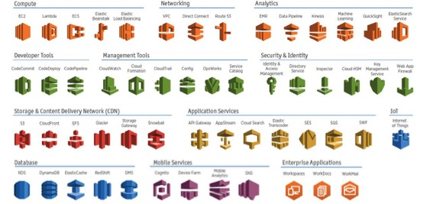

Business Background
Talaura Technologies serves growth-focused offline retailers who want to unlock hidden revenue in their physical stores by understanding every in-store sales conversation. These retailers care about diagnosing lost sales, ensuring SOP and playbook adherence on the shop floor, and gaining 100% visibility into how salespeople actually engage with walk-ins across regions and formats. They typically operate in experience-driven categories such as luxury clothing, home decor, automotive, and jewellery, where objections, value articulation, and cross-sell opportunities directly influence conversion and ticket size. These customers seek a secure, low-friction solution that can capture conversations via in-store devices, run AI-powered analysis tuned to their industry, and deliver role-based, actionable dashboards to managers, sales leaders, and central teams. Ultimately, they are looking for measurable uplift in store revenues and an authentic, unfiltered voice-of-customer data stream to inform sales coaching, marketing, and product decisions.

Talaura Technologies would be referred as ‘Customer’ or ‘CUSTOMER’, thereafter.

Customer Project(s) Overview
Talaura Technologies is requires the following resources and configuration for their workload:
- Total no. of Application Servers: 04
- Application Stack:
  - Front-end: React
  - Backend: FastAPI/Django
- Code Repository: GitHub

Problem Statement
The customer is currently operating their core Talaura Technologies retail intelligence platform on on-premise infrastructure and is experiencing increasing constraints around scalability, reliability, performance, and security as their customer base, data volumes, and AI/ML workloads grow. To address these challenges and establish a future-ready foundation, the customer has decided to migrate their application and data stack to a hyperscale public cloud provider, with a strong preference for Amazon Web Services (AWS), following a lift-and-shift approach as the first phase, with room for later modernization. They are specifically seeking an AWS Partner who can design, implement, and migrate to a cloud architecture that adheres to AWS Well-Architected best practices across security, cost optimization, operational excellence, performance efficiency, and reliability, while minimizing downtime.

Document Objective
This document describes the Scope of Work for the AWS Cloud Consulting, Cloud Architecture, Infra Setup, App Deployments and Managed Services, whatever is applicable & related to CUSTOMER application.

This Project Scope is the complete and exclusive agreement that replaces any prior oral or written communications, representations, understandings, warranties, promises, covenants, commitments, or agreements between the parties with respect to the subject matter of the Agreement.

By signing in the Acceptance section (end of the document) both Parties agree to be bound by the terms of this Agreement, and once signed, unless prohibited by the applicable law, any reproduction of this Agreement made by reliable means (Photocopy or Facsimile) is considered original.

Success Criteria
Below are the success criteria for the project to be deemed as a success:
- Setup AWS Infrastructure as per architecture Section 8
- Provide Infrastructure level Support to Customer while they perform required testing on the applications.
- Project Go-Live and signoff from customer for successful delivery.
Note:
- Infra deployment to be done on Prod Environment.
- Any parameters taken during the discovery phase, adding to the complexity of the project shall be considered as Change Request and shall follow the Change Management Process.

Proposed Solution & Architecture
To address the objectives defined in the problem statement, Rapyder proposes the AWS Cloud Deployment Architecture below. Best practices and business continuity principles are factored in during the solutioning and based on the same following considerations and Architecture Approach are being taken.

Implementation Approach

Architectural considerations
Considering the best practices, following architectural considerations, and recommended:
Section 1: Variable Considerations
- AWS Mumbai (ap-south-1) is considered for the hosting of resources.
Section 2: Project Related Changes
- AWS account section:
- Customer to provide access to AWS Account.

- AWS Compute section:
- Install AWS MGN (Application Migration Service) agents on on-premises servers.
- Migrate existing server data from on-premises to AWS using MGN.
- Launch test EC2 instance from the latest replicated snapshot.
- Execute cutover and post migration validation of database connectivity, replication.
- Configure golden image AMIs and Launch Templates. Enable autoscaling groups on the EC2 Instances across ap-south-1a and ap-south1b.
- Rapyder to setup 04 EC2 Instances across 02 Availability Zones (ap-south-1a and ap-south-1b) in private subnets for isolation.
- Set up Amazon S3 buckets for storing logs and data with KMS encryption.

- AWS Network section:
- Create 01 VPC for Production environment.
- Create 02 public subnets and 02 private subnets across ap-south-1a and ap-south-1b in the Production VPC.
- Deploy 02 NAT Gateway in each public subnet to enable outbound internet access from private subnets.
- Configure Route53 hosted zone with environment-specific domains/aliases for respective environments.
- Route tables will be configured to ensure correct routing between resources while maintaining the required isolation.
- Configure 01 Application Load Balancer to route the traffic to the application layer.

- AWS Security section:
- Appropriate Security Group Firewall Rules would be applied to allow only Web / App traffic from the external world.
- AWS WAF to be set up to protect the application layer from the Top 10 OWASP attacks.
- Appropriate NACL Rules to be set up for all subnets in each environment to control inbound and outbound traffic.
- Amazon GuardDuty and Amazon Inspector service to be set up for continuous threat detection, vulnerability scanning and runtime security monitoring.
- AWS IAM policies to be configured as per least privilege principle.

- Observability section:
- Infra Monitoring using AWS CloudWatch would be configured. CloudWatch dashboards to be configured with defined matrices to monitor AWS infrastructure.
- AWS Budgets will be defined, and alarms will be configured.
- All the above infrastructure to be deployed using Terraform scripts with version control, remote state, and state locking.

Section 4: Generic Considerations
- VPC with required subnets, NACL’s & routing will be configured in AWS for an isolated network.
- All servers will reside in private subnets for isolation from internet and public access.
- Required IAM users/groups will be created by Rapyder, and necessary permissions will be allocated.
- Automation AMI/Snapshots, scheduling EC2 or automating response to CloudWatch alarms will be done by Rapyder, if required.
- AWS EC2 instance series & size can/will be modified later based on load / traffic needs, if required.
- Applications & DB would be setup by the customer; Infrastructure support would be provided by Rapyder.
- Instance sizing will be taken based on the best match with the information shared on the existing sizing & usage, can be changed later based on the actual usage, accordingly, will change AWS billing.
- Components shown in the architecture are for reference purposes, the same may or may not be included in the effort scope. Activities would be done as mentioned in the effort section.
- Anything apart from the activities mentioned in the document will be treated as out of scope.

Architecture Diagram – Infrastructure
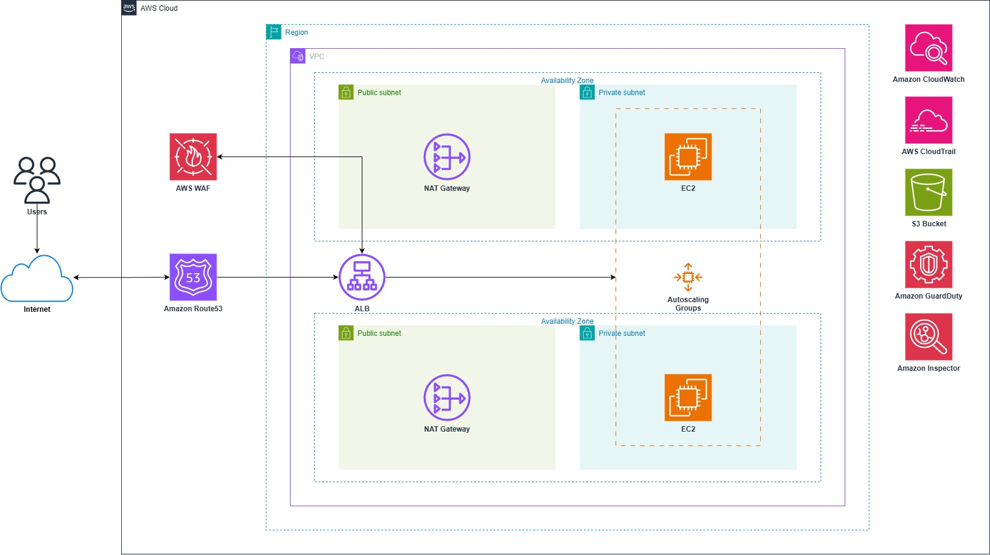
Architecture is for representational purposes only and not all the connectivity/services are shown.

Assumptions
- Customer will provide remote access to the on-premises environment for the migration.
- All application (container images) and third-party licenses are to be managed and provided by the customer.
- Customer will provide all necessary credentials, configuration files, and documentation for the application and database servers prior to migration.
- 10GB per month data ingestion to S3 bucket is taken as assumption.
- Application data (if any, to be migrated) will be provided by the customer to the Rapyder team.
- Downtime required (if any) will be given by the customer.
- Initially we consider minimum resources i.e., Internet bandwidth, storage, compute etc. Rapyder suggests performing load testing before Go-Live on AWS for the right sizing of infra.
- The AWS Cost provided here is only an estimate of your AWS fees and doesn't include any taxes that might apply. Your actual fees depend on a variety of factors, including your actual usage of AWS services.

Out of Scope:
- Application Development and configuration.
- Application-level changes will be made by the customer only. Rapyder to provide infra and
- Application connectivity and re-configurations (if any) will be done by the customer.
- Any activities not mentioned as part of this document to be considered out of scope.
- Configuration of IIS, Visual Studio, PostgreSQL, and is out of scope for this project.
- On-premises infrastructure setup or integration.

Best Practices recommendations & inclusions
Considering the best practices, the following considerations are recommended & included in the solution:

Compute Options
Compute Elements
S.Nr | Items | Inclusions/ Exclusions
 | AWS EC2 | Include: ☒ Exclude: ☐
 | AWS EKS | Include: ☐ Exclude: ☒
 | AWS ECS FOR EC2 | Include: ☐ Exclude: ☒
 | AWS Fargate | Include: ☐ Exclude: ☒
 | AWS Lambda | Include: ☐ Exclude: ☒
 | AWS API Gateway | Include: ☐ Exclude: ☒

Security considerations
Security Elements
S.Nr | Items | Inclusions/ Exclusions
 | AWS Inspector Agent | Include: ☒ Exclude: ☐
 | AWS GuardDuty | Include: ☒ Exclude: ☐
 | AWS IAM Roles/Policies | Include: ☒ Exclude: ☐
 | AWS Config | Include: ☐ Exclude: ☒
 | AWS KMS/Encryption | Include: ☒ Exclude: ☐
 | AWS Certificate Manager/SSL | Include: ☐ Exclude: ☒
 | AWS WAF | Include: ☒ Exclude: ☐
 | AWS Network Firewall | Include: ☐ Exclude: ☒

Monitoring and Logging
Monitoring and Logging
S.Nr | Items | Inclusions/ Exclusions
 | AWS CloudWatch Alarms | Include: ☒ Exclude: ☐
 | AWS CloudWatch Dashboards | Include: ☒ Exclude: ☐
 | AWS CloudWatch Logs | Include: ☒ Exclude: ☐
 | Custom metrics implementation | Include: ☒ Exclude: ☐
 | AWS X-ray | Include: ☐ Exclude: ☒
 | AWS Systems Manager | Include: ☒ Exclude: ☐

Storage
Backup Policies
S.Nr | Items | Inclusions/ Exclusions
 | EBS Storage | GP3: ☒ Cold HDD: ☐ Throughput Optimized HDD: ☐ Magnetic: ☐ PIOPS: ☐
 | EFS | Include: ☐ Exclude: ☒
 | Amazon S3 | Include: ☒ Exclude: ☐
 | Amazon Glacier | Include: ☐ Exclude: ☒
 | Amazon Storage Gateway | Include: ☐ Exclude: ☒
 | Lifecycle management rules | Include: ☒ Exclude: ☐

Backups
Backup Policies
S.Nr | Items | Inclusions/ Exclusions
 | Automated Snapshots implementation | Include: ☐ Exclude: ☒
 | Automated AMI Implementation | Include: ☐ Exclude: ☒
 | Native backups for tools | Include: ☐ Exclude: ☒

Databases/Services used
Database Sevices
S.Nr | Items | Inclusions/ Exclusions
 | Amazon RDS | Include: ☐ Exclude: ☒
 | Amazon Aurora | Include: ☐ Exclude: ☒
 | Amazon Database Migration Service | Include: ☐ Exclude: ☒
 | Amazon Dynamodb | Include: ☐ Exclude: ☒
 | Amazon Redshift | Include: ☐ Exclude: ☒
 | Amazon Elasticache | Include: ☐ Exclude: ☒

DevOps tools
DevOps Tools
S.Nr | Items | Inclusions/ Exclusions
 | Code Commit | Include: ☐ Exclude: ☒
 | Code Build | Include: ☐ Exclude: ☒
 | Code Deploy | Include: ☐ Exclude: ☒
 | Code Pipeline | Include: ☐ Exclude: ☒
 | Code Star | Include: ☐ Exclude: ☒
 | AWS Cloud9 | Include: ☐ Exclude: ☒
 | AWS Service Catalog | Include: ☐ Exclude: ☒
 | AWS ECR | Include: ☒ Exclude: ☐
 | AWS ECS FOR EC2 | Include: ☐ Exclude: ☒
 | AWS Fargate | Include: ☐ Exclude: ☒

Big Data
Big Data Services
S.Nr | Items | Inclusions/ Exclusions
 | AWS Athena | Include: ☐ Exclude: ☒
 | AWS EMR | Include: ☐ Exclude: ☒
 | AWS Elasticsearch Service | Include: ☐ Exclude: ☒
 | AWS Kinesis | Include: ☐ Exclude: ☒
 | AWS Glue | Include: ☐ Exclude: ☒
 | AWS Quicksight | Include: ☐ Exclude: ☒
 | AWS IOT Core | Include: ☐ Exclude: ☒
 | AWS IOT Greengrass | Include: ☐ Exclude: ☒
 | AWS FreeRTOS | Include: ☐ Exclude: ☒

AI/ML
Big Data Services
S.Nr | Items | Inclusions/ Exclusions
1 | Amazon SageMaker | Include: ☐ Exclude: ☒
2 | EC2 Ground Truth | Include: ☐ Exclude: ☒
3 | EC2 Neo | Include: ☐ Exclude: ☒
4 | Amazon Augmented AI | Include: ☐ Exclude: ☒
5 | Amazon Rekognition | Include: ☐ Exclude: ☒
6 | Amazon Polly | Include: ☐ Exclude: ☒
7 | Amazon Personalize | Include: ☐ Exclude: ☒
8 | Amazon Textract | Include: ☐ Exclude: ☒
9 | Amazon Transcribe | Include: ☐ Exclude: ☒

Migration/Implementation

Approach for AWS Environment Setup

Setup and Support Services
  - AWS A/c Setup or gain Access of existing Accounts with Billing configurations & alarms.
  - Design & Setup IAM Rules, Group and Users
  - Provide/create access to Rapyder and Customer
  - AWS Network & Infra Setup
- Setting-up other AWS Components and Services considered for these environments (As Applicable) – VPC, NAT, Public/ Private Subnets, Security Groups, RDS, EBS, S3, AWS CloudWatch etc.
  - Setting up Environments as per Architecture
- Delete orphan resources such as existing EC2 instance, and EIP after Go-Live to newly created environment once customer approval is received.
- Other activities related to AWS Infrastructure setup; details are mentioned in the implementation plan.
- Technology / Tools Stack will be deployed by Customer/ Rapyder to various Virtual Machines & AWS Services as per need. Details provided in effort section table.
- Creating VM Snapshots of all environments instances before deploying Application
- Maintaining two recent AMI’s (Before doing any change in running Instance will be taking AMI’s)
- Security in terms of firewall, access would be restricted as per the individual application/ component owners.
- Backup of critical data in S3 bucket, encryption of data will be done (as needed)
- Automation of AWS Snapshot based backup.

Security Setup
The security setup for the customer will be as per the AWS best practices according to the Startup Security Baseline (SSB).
https://docs.aws.amazon.com/prescriptive-guidance/latest/aws-startup-security-baseline/welcome.html

Activities for Securing AWS Account
SSB Activity | Downtime Expected | Approach Suggested | Included (Y/N)
Confirming that root email is Monitored | NA | Discussion-Change to a monitored email if not regularly monitored | Yes
Addition of Account Level Contacts | NA | Update from Account Settings | Yes
Create IAM Groups for groups of users | NA | IAM Console | Yes
Create IAM Policy for Group of users | NA | IAM Console | Yes
Create IAM User for each user | NA | IAM Console | Yes
Enable MFA for Root Accounts | NA | IAM Console | Yes
Trigger notifcation on Root Account Usage |  | Cloud | Yes
Enforce MFA for IAM Users | NA | IAM Console
Enforce Password Policy | NA | IAM Console | Yes
Enable CloudTrail Logs delivery to S3 | NA | CloudTrail Console | Yes
Prevent S3 bucket public access | NA | Enable public Access through CloudFront for public contents | Yes
Delete Unused resources | NA | AWS Console | Yes
Enable AWS Budget | NA | Budget Console | Yes
Enable GuardDuty | NA | GuardDuty Console | Yes
Create CloudWatch Event rule for notifying on GuardDuty Findings | NA | EventBridge + SNS | Yes
Review Trusted Advisor and Resolve high-risk issue | NA | Trusted Advisor | Yes

Dependencies
- RPO / RTO Objectives and Compliance related requirements to be provided by Customer.
- Business Requirement (Use Case Document) and Workflow diagram to be provided for all components by the Customer

Assumptions
- Customer will provide AWS Account and Provide admin access to Rapyder, which will be used to setup AWS IAM setup & for launching needed AWS Services, Instances and DB’s.
- AWS Region considered for the Migration & Deployment is Mumbai region (ap-south-1).
- Any Limitation of AWS service will be applicable in the current implementation.
- The Rapyder Cloud Team will provide the necessary Instances / Services for hosting environment(s).
- Task distribution between Customer and Rapyder team to be decided and agreed upon timelines for the delivery as part of the project plan.
- Customer will take care of deployment and configuration changes as far as the applications are concerned.
- AWS Sizing for implementation will be used as per the specification provided before implementation. The AWS cost will vary based on the instances / services size, type & quantity.
- While implementation, we will start on demand & based on the actual usage the right instance type / size would be recommended for further reservations.
- Customer to take care of configuration of the application due to IP changes and end point changes.
- Based on frequency of snapshot and S3 backups, the AWS cost will vary.
- All third-party tools or application licenses for the hardware and software required for the project will be borne by the customer.

Scope of Project, Activities and Schedule
Below are the details of Project Scope with owner details.

Project Plan and Work Break Down List
Project Plan and Work Break Down List
Infrastructure Creation and Implementation
AWS Accounts and Basic Networking Setup
Roles | Sub task | Effort required (person days)
Sr. Solutions Architect | Discuss with the Application team and understand the current application dependencies | 1
Sr. Solutions Architect | Create Document, Reviews from Customer, Corrections and Document sign off | 1
Sr. Cloud Engineer | AWS Account Creation/ Setup or Gain access if existing A/C (Roles, Policies, Groups and Users) Access Setup | 0.5
Sr. Cloud Engineer | Setup Basic Networking (Create 01 VPC, subnets, route tables, security groups, NACL, NAT Gateways and tags) | 1
Sr. Cloud Engineer | Configure ALB, WAF (OWASP core rules), Route53 DNS | 1
 | Total | 3.5
Production Environment Setup
Roles | Sub task | Effort required (person days)
Sr. Cloud Engineer | Provision 04 EC2 instances (g6.4xlarge) in private subnet across 02 Availability Zones (ap-south-1a and ap-south 1b).  Configure golden image AMIs and Launch Templates. Enable autoscaling groups on the EC2 Instances across ap-south-1a and ap-south1b. | 1
Sr. Cloud Engineer | Install and configure AWS MGN (Application Migration Service) agents on the on-premises servers.  Migrate application data from on-premise servers to Amazon EC2 Instances using MGN.  Execute cutover post validation of connectivity. | 1.5
Sr. Cloud Engineer | Setup S3 bucket for logs and data ingestion. | 0.25
Sr. Cloud Engineer | Handover of Infra to App team for testing before Go-Live. Changes as per the need.  Infra. and App support while testing the application.  - Rapyder to support at infrastructure level. | 2
Sr. Cloud Engineer | Application Go-live Support | 1
 | Total | 5.75
AWS Security and Monitoring Tools
Roles | Sub task | Effort required (person days)
Sr. Cloud Engineer | Configure AWS Budgets and cost alerts. | 1
Sr. Cloud Engineer | Configure CloudWatch monitoring and Enable CloudTrail in Mumbai region. | 2.5
Sr. Cloud Engineer | Configure dashboards with custom metrics and alarms for centralized monitoring of resources. | 2.5
Sr. Cloud Engineer | Enable Amazon GuardDuty for threat detection and configure findings notifications. | 0.5
Sr. Cloud Engineer | Enable Amazon Inspector for vulnerability assessment of EC2 instances and configure scanning schedules. | 0.5
 | Total | 4.5
Documentation and Post Go-Live Support
Roles | Sub task | Effort required (person days)
Sr. Cloud Engineer | Documentation of entire project  -Infra Support the customer application team for testing  -handover the Infra. to customer | 0.5
Sr. Cloud Engineer | Post Go-Live Support of entire setup environment (1.5 Hours/Day for 4 Working Week) | 8.75
 | Total | 9.25
Project Management
Roles | Sub task | Effort required (person days)
Project Manager | PMO team will conduct governance with Technical Team and Customer Stakeholders | 1
 | Total | 1

Risks, Assumptions and Dependencies
- The effort shown in the above tables is from a planning perspective and subjected to change based on the overall approach for implementation.
- During planning, key decisions will need to be taken in a timely fashion.
- The effort shown in the above tables is from a planning perspective and subjected to change based on the overall approach for implementation.
- During planning, key decisions will need to be taken in a timely fashion.
- Customer will do the performance testing of the deployment to suggest the right sizing of the AWS infra before reserving the instances.
- VAPT testing should be planned to make infrastructure DDoS attacks resilient.
- There may be single point of failure in this deployment architecture, with no data replication planned, data recovery will be based on the back up frequency decided during the detailed implementation.
- Below is the RACI Matrix defined for the migration activity:

Project Governance

Governance Model
The following is the governance model that will be followed during this engagement:
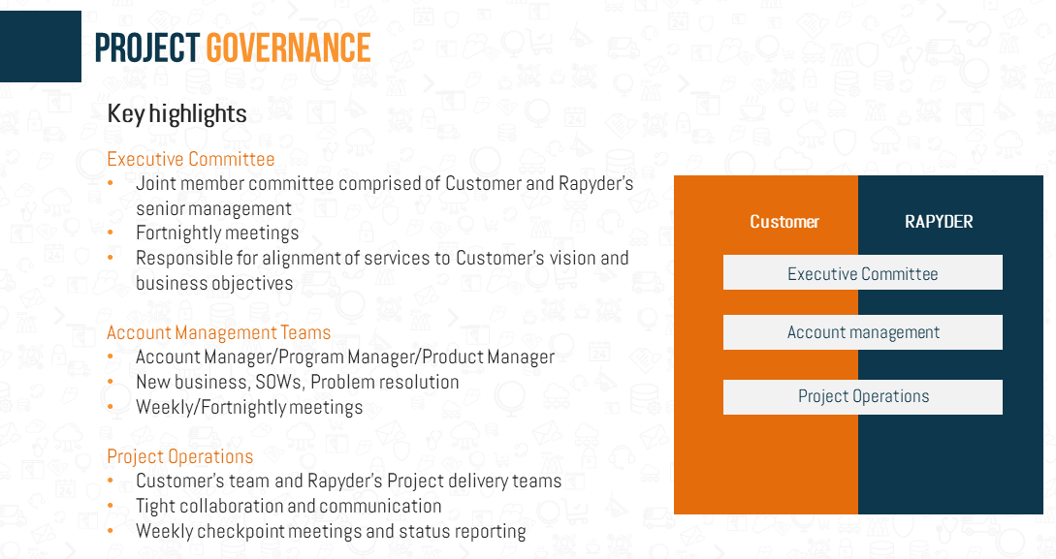

Escalation Matrix
Following is the escalation matrix:
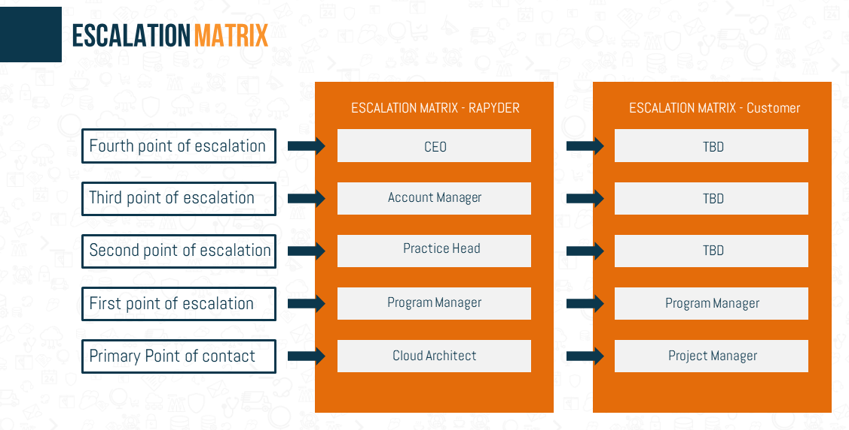

Governance Report
The following is the Governance Report that will be shared on weekly basis:
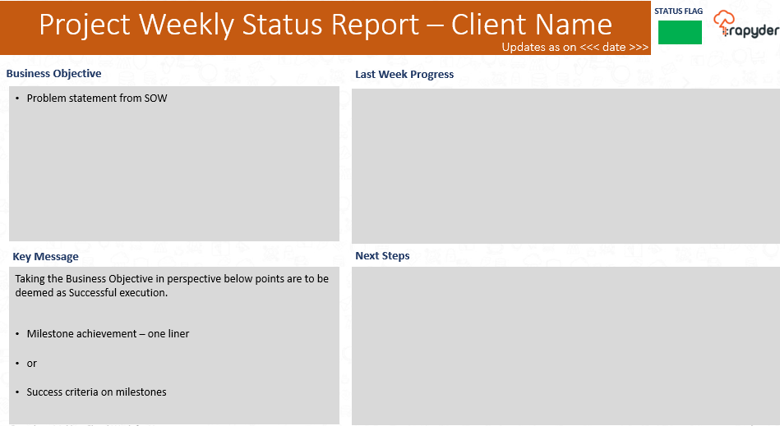

Out of Scope
- Infrastructure running cost (if any) will be directly paid by CUSTOMER to AWS
- Any Product(s) not listed in this document are out of scope.
- Application-level Management & DR (interruptions/outages due to functionality issues, bugs etc.) will be customer responsibility.
- Issues related to application configuration, setup, and stability along with application testing.
- The following non-functional requirements are out of scope of this migration activity:
- Issues regarding the working of application is responsibility of the customer.
- Application Load Testing and Benchmarking is responsibility of the customer.
- No SLA’s are defined in terms of application up-time, latency, and availability.
- Issues due to DOS attacks (Denial of Service), Malware, Virus and Security related issues. However, these will be attended on a best effort basis and charged as per the efforts.
- Disaster Recovery outside the Primary Region is not factored in the design.
- Any unplanned changes to the AWS Design, Deployment or Infrastructure will be out of Scope activities & must go under a Change Management Process.
- Changes supported may include addition or removal of servers having the agreed tech stack. New technology stack support will be considered as change request.
- Roll back plan in case of any changes / issues.
- Management of the application is responsibility of the client, unless specifically defined. Infra support is the responsibility of Rapyder.
- All third-party tools or application licenses for the hardware and software required for project will be borne by the customer.
- Any Security / Legal Compliance audit.

Acceptance Criteria
Rapyder acknowledges that it understands all Deliverables and has the knowledge and resources to complete all Deliverables in conformity with the Acceptance criteria for the Deliverable(s). Rapyder acknowledges that the Fees set forth in this SOW cover all deliverables and required corrections to same to satisfy SOW requirements (including Acceptance Criteria).

Deliverables
At high level, the below are the deliverables:
- Design
  - AWS Deployment Architecture Document
  - Technical Spec for each step and Process of Application Architecture.
  - IAM Roles, Users Access Document
- Implementation
  - Implementation Document
    - Security Setup details
    - Services and Instances details
    - Networking Details
- Signoff Requirement
The client is required to sign off the completion of the project.
Party | Contribution (USD) | % Contribution of Total
Customer | TBD | TBD
APN Partner | TBD | TBD
AWS | TBD | TBD
Project Deliverables
(Estimated / Actual) Project Start Date |  | TBD
(Estimated / Actual) Project End Date |  | TBD
Expected Date of Production |  | TBD
Customer’s AWS Account ID for Production (If any) |  | TBD
Public reference if project successful? (Yes / No) |  | TBD
Case study potential if project successful? (Yes / No) |  | TBD

RACI Matrix
Responsible | Those who do the work to achieve the task. There is at least one role with a participation type of responsible, although others can be delegated to assist in the work required (see also RASCI below for separately identifying those who participate in a supporting role).
Accountable | The one ultimately answerable for the correct and thorough completion of the deliverable or task, and the one who delegates the work to those responsible and manages them.
Consulted | Those whose opinions are sought, typically subject matter experts; and with whom there is two-way communication.
Informed | Those who are kept up to date on progress, often only on completion of the task or deliverable and with whom there is just one-way communication.
Support | Resources allocated to responsible who, unlike the consulted, may provide input to the task and support or help complete the task.

S.No | Activity | Rapyder | Customer
1 | Discuss Application and Infrastructure Architecture. Understand Dependencies and Integration points. | R,A | C,I,S
2 | Understand the Customer Business Strategies, priorities, and Requirements | R,A | C,I,S
3 | Provide complete Business Requirement understanding. | C,I | R,A,S
4 | Provide Access of AWS Account (Admin Access) | C,I | R,A,S
5 | Setting up Infra for Prod environment as defined in scope | R, A | C, I
7 | Deployment & configuration of application. | C, I | R, A
8 | DB Infrastructure setup, installation & configuration. | C, I | R, A
9 | Testing & validation of Infra setup | R, A | C, I
10 | Testing & validation of Application setup | C, I | R, A
11 | Testing & validation of Data | C, I | R, A

Pricing

AWS Cost Estimates
S. No | Service | Configuration summary | Monthly (USD)
1 | Amazon EC2 | Tenancy (Shared Instances), Operating system (Linux), Workload (Consistent, Number of instances: 4), Advance EC2 instance (g6.4xlarge), Pricing strategy (On-Demand Utilization: 100 %Utilized/Month), Enable monitoring (enabled), EBS Storage amount (500 GB), DT Inbound: Not selected (0 TB per month), DT Outbound: Internet (1 TB per month), DT Intra-Region: (0 TB per month) | 5045.28
2 | Network Address Translation (NAT) Gateway | Number of Regional NAT Gateways (1), Number of Availability Zones Regional NAT Gateways is active in (2) | 92.96
3 | Application Load Balancer | Number of Application Load Balancers (1) | 19.79
4 | S3 Standard | S3 Standard storage (10 GB per month), PUT, COPY, POST, LIST requests to S3 Standard (10000), GET, SELECT, and all other requests from S3 Standard (10000) | 0.30
5 | Amazon Route 53 | Hosted Zones (1) | 0.50
6 | AWS Web Application Firewall (WAF) | Number of Web Access Control Lists (Web ACLs) utilized (1 per month), Number of Managed Rule Groups per Web ACL (10 per month) | 15.00
7 | Amazon GuardDuty | EBS Volume Data Scan Analysis (2 TB per month) | 22.00
8 | Amazon Inspector | Average* No. of EC2 instances scanned per month (4) | 6.04
9 | Amazon CloudWatch | Number of mobile OTEL events and spans or spans per visit (70), Mobile sampling rate (1), Number of Metrics (includes detailed and custom metrics) (40), Number of Dashboards (1), Number of Standard Resolution Alarm Metrics (10) | 13.00
10 | AWS CloudTrail | Management events units (millions), Management event trails (1), Read management trails (1), Data events units (millions), S3 trails (1), Lambda trails (1), Network activity events units (millions), Network activity event trails (1), Insight events units (millions), Number of trails and/or event data stores where Insights events are enabled (1) | 0.00
Total |  |  | $5214.87

AWS Calculator Link: - https://calculator.aws/#/estimate?id=f10495be9e443d1f72e100979815d9ed64d74ddf

Rapyder Implementation Charges
The Effort & Cost of AWS Implementation (Reference) is as below: -
Implementation Effort & Charges
Activity Head | Effort required (person days) | Total (USD)
AWS Accounts and Basic Networking Setup | 3.50 | TBD
Production Environment Setup | 5.75 | TBD
AWS Security and Monitoring Tools | 4.50 | TBD
Documentation and Post Go-Live Support | 9.25 | TBD
Project Management | 1.00 | TBD
Grand Total | 24.00 | TBD
Note: Actual effort will be pulled in by deploying multiple resources.

Payment Terms
Milestone | Activity | Sign Off required (Yes / No) | Payment (in %)
Milestone - 01 | After SOW Sign Off (Advanced Payment) | Yes | 35%
Milestone - 02 | Prod Environment Setup  Migration | Yes | 35%
Milestone - 03 | Post Final Go-Live and Project Kick Off | Yes | 30%

Invoices will be raised in INR as per the agreed terms. The customer would be responsible for approval of all invoices based on a net 7-day payment terms. Change in scope will be managed by Change Management Process. In the event of change in scope, the revised cost will be added to the total original proposed cost of the project.

Assumptions
Rapyder has the following assumptions regarding this project:
- The scope is defined based on the process knowledge shared by Customer and documented in the project scope section.
- Customer will be fully responsible for providing clear business requirements and will sign off the requirements document prior to the start of the development phase.
- Purchase or provisioning of any hardware/software for development or actual deployment, outside of the scope agreed, and shall be out of Rapyder's scope.
- Complete infrastructure and support facilities to be provided by Customer for onsite work. (E.g. project rooms, meeting and training rooms, equipment, PCs, phones, and network infrastructure).
- Customer will undertake responsibility for change management with significant input from us as to the overall approach, strategy, and structure.
- Network performance and stability will be the responsibility of DC and will be governed by AWS SLA.
- Customer shall designate a single point of contact (SPOC) for all its project related communications.
- Customer shall provide Project Manager with the required knowledge (documents, demos, etc.) to successfully execute the project.
- Customer’s SPOC shall inform Rapyder for any non-performance issues / non-conformance.
- Key decisions regarding the direction of the project, resolution to conflicts, and other areas requiring direction will be taken quickly and in a focused manner.
- Any modifications identified as gaps in the Statement of Work, based on what is listed in the scope section, will be taken forward as per the change request management process. Following which if required these will be estimated for effort & overall cost would be provided to the customer.
- Customer will be responsible for developing any custom training materials and rolling out training to end users, if and where applicable.
- Customer shall govern and be the complete owner of all the applications deployed, policy definition etc.
- All prices quoted do not include any taxes. GST would be extra as applicable at the time of Invoicing (it is currently 18.00%)

AWS Service Level Agreements
AWS commits to offer Service Level Agreements (SLAs) and publish Service Level Objectives (SLOs) for all paid, generally available services.
AWS Services | SLA Definition
AWS S3 | https://aws.amazon.com/s3/sla/?did=sla_card&trk=sla_card
AWS EC2 | https://aws.amazon.com/compute/sla/?did=sla_card&trk=sla_card
AWS Dynamo DB | https://aws.amazon.com/dynamodb/sla  Amazon Dynamo DB SLA
Route 53 | https://aws.amazon.com/route53/sla/
AMAZON ELASTIC CONTAINER SERVICE FOR KUBERNETES (ECS FOR EC2) | https://aws.amazon.com/ECS for EC2/sla/?did=sla_card&trk=sla_card
AWS CLIENT VPN | https://aws.amazon.com/vpn/client-vpn-sla/?did=sla_card&trk=sla_card
AMAZON MESSAGING (SQS, SNS) | https://aws.amazon.com/messaging/sla/?did=sla_card&trk=sla_card
AMAZON LIGHTSAIL INSTANCE AND BLOCK STORAGE | https://aws.amazon.com/lightsail/sla-lightsail-instances-and-block-storage/?did=sla_card&trk=sla_card
AWS COMPUTE OPTIMIZER | https://aws.amazon.com/compute-optimizer/sla/?did=sla_card&trk=sla_card
AWS LAMBDA | https://aws.amazon.com/lambda/sla/?did=sla_card&trk=sla_card
AWS SITE-TO-SITE VPN | https://aws.amazon.com/vpn/site-to-site-vpn-sla/?did=sla_card&trk=sla_card
AWS FARGATE AND AMAZON ELASTIC CONTAINER SERVICE (MULTI-AZ) | https://aws.amazon.com/ecs/sla/?did=sla_card&trk=sla_card
AMAZON AURORA | https://aws.amazon.com/rds/aurora/sla/?did=sla_card&trk=sla_card
AMAZON CLOUDSEARCH | https://aws.amazon.com/cloudsearch/sla/?did=sla_card&trk=sla_card
AMAZON DOCUMENTDB (WITH MONGODB COMPATIBILITY) | https://aws.amazon.com/documentdb/sla/?did=sla_card&trk=sla_card
AMAZON DYNAMODB (GLOBAL TABLES SLA) | https://aws.amazon.com/dynamodb/sla/?did=sla_card&trk=sla_card
Amazon EventBridge | https://aws.amazon.com/eventbridge/sla/?did=sla_card&trk=sla_card
AMAZON MWAA | https://aws.amazon.com/managed-workflows-for-apache-airflow/sla/?did=sla_card&trk=sla_card
AMAZON MQ | https://aws.amazon.com/amazon-mq/sla/?did=sla_card&trk=sla_card
AWS STEP FUNCTIONS | https://aws.amazon.com/step-functions/sla/?did=sla_card&trk=sla_card
AWS BUDGETS | https://aws.amazon.com/aws-cost-management/aws-budgets/sla/?did=sla_card&trk=sla_card
AWS COST EXPLORER API | https://aws.amazon.com/aws-cost-management/aws-cost-explorer/sla/?did=sla_card&trk=sla_card
AWS CODEARTIFACT | https://aws.amazon.com/codeartifact/sla/?did=sla_card&trk=sla_card
AWS CODEBUILD | https://aws.amazon.com/codebuild/sla/?did=sla_card&trk=sla_card
AWS CODECOMMIT | https://aws.amazon.com/codecommit/sla/?did=sla_card&trk=sla_card
AWS CODEDEPLOY | https://aws.amazon.com/codedeploy/sla/?did=sla_card&trk=sla_card
AWS CODEPIPELINE | https://aws.amazon.com/codepipeline/sla/?did=sla_card&trk=sla_card
AWS X-RAY | https://aws.amazon.com/xray/sla/?did=sla_card&trk=sla_card
AMAZON APPSTREAM 2.0 | https://aws.amazon.com/appstream2/sla/?did=sla_card&trk=sla_card
AMAZON WORKSPACES | https://aws.amazon.com/workspaces/sla/?did=sla_card&trk=sla_card
AMAZON API GATEWAY | https://aws.amazon.com/api-gateway/sla/?did=sla_card&trk=sla_card
AWS AMPLIFY CONSOLE | https://aws.amazon.com/amplify/sla/?did=sla_card&trk=sla_card
AWS APPSYNC | https://aws.amazon.com/appsync/sla/?did=sla_card&trk=sla_card
AWS IOT ANALYTICS | https://aws.amazon.com/iot-analytics/sla/?did=sla_card&trk=sla_card
AWS IOT CORE | https://aws.amazon.com/iot-core/sla/?did=sla_card&trk=sla_card
AMAZON DEVOPS GURU | https://aws.amazon.com/devops-guru/sla/?did=sla_card&trk=sla_card
AMAZON FORECAST | https://aws.amazon.com/forecast/sla/?did=sla_card&trk=sla_card
AMAZON KENDRA | https://aws.amazon.com/kendra/sla/?did=sla_card&trk=sla_card
AMAZON REKOGNITION | https://aws.amazon.com/rekognition/sla/?did=sla_card&trk=sla_card
AMAZON SAGEMAKER | https://aws.amazon.com/sagemaker/sla/?did=sla_card&trk=sla_card
AMAZON TEXTRACT | https://aws.amazon.com/textract/sla/?did=sla_card&trk=sla_card
AMAZON CLOUDWATCH | https://aws.amazon.com/cloudwatch/sla/?did=sla_card&trk=sla_card
AMAZON MANAGED GRAFANA | https://aws.amazon.com/grafana/sla/?did=sla_card&trk=sla_card
AWS CLOUDTRAIL | https://aws.amazon.com/cloudtrail/sla/?did=sla_card&trk=sla_card
AWS CONFIG | https://aws.amazon.com/config/sla/?did=sla_card&trk=sla_card
AWS RESILIENCE HUB | https://aws.amazon.com/resilience-hub/sla/?did=sla_card&trk=sla_card
AWS SERVICE CATALOG | https://aws.amazon.com/servicecatalog/sla/?did=sla_card&trk=sla_card
AWS SYSTEMS MANAGER | https://aws.amazon.com/systems-manager/sla/?did=sla_card&trk=sla_card
AWS APPLICATION MIGRATION SERVICE (MGN) | https://aws.amazon.com/application-migration-service/sla/?did=sla_card&trk=sla_card
AWS DATABASE MIGRATION SERVICE (DMS) | https://aws.amazon.com/dms/sla/?did=sla_card&trk=sla_card
AWS MAINFRAME MODERNIZATION | https://aws.amazon.com/mainframe-modernization/sla/?did=sla_card&trk=sla_card
AMAZON CLOUDFRONT | https://aws.amazon.com/cloudfront/sla/?did=sla_card&trk=sla_card
AMAZON ELASTIC LOAD BALANCING SERVICE | https://aws.amazon.com/elasticloadbalancing/sla/?did=sla_card&trk=sla_card
AMAZON ELASTIC LOAD BALANCING SERVICE (SINGLE-AZ) | https://aws.amazon.com/elasticloadbalancing/sla/?did=sla_card&trk=sla_card
AMAZON ROUTE 53 | https://aws.amazon.com/route53/sla/?did=sla_card&trk=sla_card
AMAZON VPC NAT GATEWAY | https://aws.amazon.com/vpc/sla/?did=sla_card&trk=sla_card
AWS DIRECT CONNECT (UPTIME TARGET 99.9%) | https://aws.amazon.com/directconnect/sla/?did=sla_card&trk=sla_card
AWS GLOBAL ACCELERATOR | https://aws.amazon.com/global-accelerator/sla/?did=sla_card&trk=sla_card
AWS PRIVATELINK SERVICE (MULTI-AZ) | https://aws.amazon.com/privatelink/sla/?did=sla_card&trk=sla_card
AWS TRANSIT GATEWAY (MULTI-AZ) | https://aws.amazon.com/transit-gateway/sla/?did=sla_card&trk=sla_card
AMAZON COGNITO | https://aws.amazon.com/cognito/sla/?did=sla_card&trk=sla_card
AMAZON DETECTIVE | https://aws.amazon.com/it/detective/sla/?did=sla_card&trk=sla_card
AMAZON GUARDDUTY | https://aws.amazon.com/guardduty/sla/?did=sla_card&trk=sla_card
AMAZON INSPECTOR | https://aws.amazon.com/inspector/sla/?did=sla_card&trk=sla_card
AMAZON MACIE | https://aws.amazon.com/macie/sla/?did=sla_card&trk=sla_card
AWS CLOUDHSM | https://aws.amazon.com/cloudhsm/sla/?did=sla_card&trk=sla_card
AWS FIREWALL MANAGER | https://aws.amazon.com/firewall-manager/sla/?did=sla_card&trk=sla_card
AWS KEY MANAGEMENT SERVICE (KMS) | https://aws.amazon.com/kms/sla/?did=sla_card&trk=sla_card
AWS SECRETS MANAGER | https://aws.amazon.com/secrets-manager/sla/?did=sla_card&trk=sla_card
AWS SECURITY HUB | https://aws.amazon.com/security-hub/sla/?did=sla_card&trk=sla_card
AWS SHIELD ADVANCED | https://aws.amazon.com/shield/sla/?did=sla_card&trk=sla_card
AWS WAF | https://aws.amazon.com/waf/sla/?did=sla_card&trk=sla_card
AMAZON ELASTIC FILE SYSTEM | https://aws.amazon.com/efs/sla/?did=sla_card&trk=sla_card
AMAZON ELASTIC BLOCK STORE | https://aws.amazon.com/ebs/sla/?did=sla_card&trk=sla_card
AMAZON FILE CACHE SERVICE | https://aws.amazon.com/filecache/sla/?did=sla_card&trk=sla_card
AMAZON FSX | https://aws.amazon.com/fsx/sla/?did=sla_card&trk=sla_card
AMAZON S3 REPLICATION TIME CONTROL FEATURE | https://aws.amazon.com/s3/sla-rtc/?did=sla_card&trk=sla_card
AMAZON SIMPLE STORAGE SERVICE (S3) | https://aws.amazon.com/s3/sla/?did=sla_card&trk=sla_card
AWS BACKUP | https://aws.amazon.com/backup/sla/?did=sla_card&trk=sla_card

Terms and Conditions

Change Management
Change management refers to the formally agreed upon approach between Rapyder Cloud Solutions and Customer to create or raise additional Scope of Work or Work extensions not captured in the original scope of work. Rapyder Cloud Solutions and Customer will mutually agree to a formal Change management request to accommodate any such changes that either add to scope of existing Design, Implementation or Service Assurance or modify existing scope. Pricing changes that accompany change management will be considered as additional price items over existing commercial terms.
S. No | Activity | Owner
1 | Client comes up with a query/change | Client
2 | Rapyder Project Delivery team to review the change against the SOW and confirm there is a change | Rapyder Project Delivery team
3 | Initial Communication to the client about Change Request. Initiate Change Request discussion | Client & Account/Sales Manager
4 | Requirement discussion and finalization | Rapyder Project Delivery team
5 | Impact analysis document capturing:  - Impact to schedule  - Additional effort needed - changing delivery timeline.  - Risks (technology)  - Additional asks from the customer | Rapyder Project Delivery team
6 | Costing of change request and approval/sign off from the client | Account / Sales Manager
7 | After confirmation, timeline for implementation to be planned and shared with the client | Rapyder Project Delivery team

Jurisdiction
This Agreement shall be governed and interpreted in accordance with the laws of India and courts at Bangalore shall have the exclusive jurisdiction to decide upon any dispute or litigation between the Parties to this Agreement.

Travel
Any Travel expenses for travel outside Bangalore the cost of travel on actuals will be reimbursed by the Customer. The travel cost will include Flight Tickets, Boarding/ Lodging, Food, Cabs etc.

Indemnification
The indemnification obligations set forth in this Section shall be the parties' exclusive rights and remedies with respect to this Agreement.
Indemnity by Customer- Customer shall indemnify and hold harmless Rapyder, Rapyder 's affiliates, and each of their respective officers, directors, members, agents and employees from and against any and all claims, demands, liabilities, obligations, losses, damages, penalties and fines of any kind and nature whatsoever (including reasonable attorneys' fees) brought by a third party under any theory of legal liability arising out of or related to any of the following: (i) the actual or alleged use of the Services in violation this Agreement or (c) applicable law or (ii) any breach by Customer of any of its obligations under this Agreement.
Reciprocal Indemnification - Each party shall indemnity and hold harmless the other party, the other party's affiliates, and each of their respective officers, directors, members, agents and employees from and against any and all claims, demands, liabilities, obligations, losses, damages, penalties and fines of any kind and nature whatsoever (including reasonable attorneys' fees) brought by a third party under any theory of legal liability arising out of or related to the indemnifying party's actual or alleged: (i) gross negligence, (ii) willful misconduct or (iii) infringement or misappropriation of a third party's copyright, trade secret, patent, trademark or other intellectual property right.

Termination
This Agreement will be in effect from signing of the agreement to 1 year. This agreement may be terminated on the on occurrence of any of the events mentioned below:
- Either party hereto commits breach of any provisions of this Agreement or fails to perform any obligation under this Agreement or the party who is alleged to have committed such breach or failed in performance is served with Thirty (30) days’ notice by the other party in writing.

- Either party may terminate this agreement.
  - Consulting/ Implementation: Upon written notice of thirty (30) days to the other Party. The duties of non-disclosure as set forth herein shall continue during the term of this Agreement and shall survive up to a period of one (1) year from termination or expiry of this Agreement.
  - Managed Services (if applicable): Upon written notice of sixty (60) days to the other Party. The duties of non-disclosure as set forth herein shall continue during the term of this Agreement and shall survive up to a period of one (1) year from termination or expiry of this Agreement.
On termination for whatever reason, “Customer” will be responsible for all Fees payable to “Rapyder” and all expenses incurred by the “Rapyder” on behalf of “Customer” up to the date termination takes effect.

NOTICES AND COMMUNICATION
Any notice/communication to be given under this Agreement will be in writing and sent to the registered address of the appropriate party or to such other address as such party may have specified by prior written notice to the other party. Such notice/communication shall be deemed given if it is made through personal delivery, registered post, and courier or through electronic media such as Telex, Fax, Cable or E-mail. Any evidence showing such a communication will be sufficient proof of the same having been made and the parties hereto shall abide by the same.

References
Company authorizes Rapyder to publish and use, purely for advertising and publicity purposes, its logo to identify Company as a customer of Rapyder websites operated by Rapyder, including the website at www.rapyder.com, and any subpages of the RCS sites, and in customer lists, commercial presentations, flyers, brochures, newsletters and other marketing collateral.
Rapyder on its part, makes a representation to the effect that no copyright, trademark, or other proprietary right of any person or entity will be violated. If at any time the Customer would like Rapyder to discontinue future use of the Items, upon email notice to Rapyder at case-study@rapyder.com (or such other email address as Rapyder directs), Rapyder will promptly discontinue future use, provided that Rapyder will not be required to remove the Item(s) from any pre-printed materials.

Acceptance and Signatories of the Proposal
The undersigned hereby agree to all terms and conditions herein and authorizes commencing the project described in this SOW document.
Talaura Technologies | Rapyder Cloud Solutions Private Limited
Address: | Address:  Rapyder Cloud Solutions Pvt. Ltd.
Signature: ________________________________________  (Authorised representative) | Signature: _______________________________________  (Authorised representative)
Name: Mr. | Name:
Title: | Title:
Date: __________________________________________ | Date: <Date>

